Check sheet

Purpose
The check list is a disciplined system for data collection.

Main Description
The check sheet is a simple document that is used for collecting data in real-time and at the location where the data is generated. The document is typically a blank form that is designed for the quick, easy, and efficient recording of the desired information, which can be either quantitative or qualitative. When the information is quantitative, the check sheet is sometimes called a tally sheet.
A defining characteristic of a check sheet is that data is recorded by making marks ("checks") on it. A typical check sheet is divided into regions, and marks made in different regions have different significance. Data is read by observing the location and number of marks on the sheet. 5 Basic types of Check Sheets:
- Classification: A trait such as a defect or failure mode must be classified into a category
- Location: The physical location of a trait is indicated on a picture of a part or item being evaluated
- Frequency: The presence or absence of a trait or combination of traits is indicated. Also number of occurrences of a trait on a part can be indicated
- Measurement Scale: A measurement scale is divided into intervals, and measurements are indicated by checking an appropriate interval
- Check List: The items to be performed for a task are listed so that, as each is accomplished, it can be indicated as having been completed

We can have two, three or even four factor check sheets. Example –

Two factor check sheet –
Find below an example of a check list for evaluating a check sheet. It shows the recording of defect over time for a machine. Only two factors are involved. They are –
- Defect category
- Time of occurrence

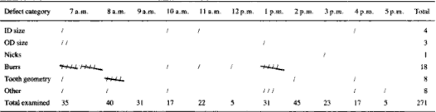
Three factor check sheets – Factors are -
- Down time cause
- Time of occurrence
- Machine

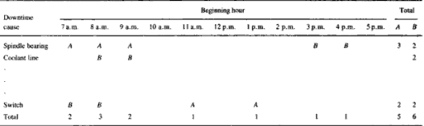

Four factor check sheets – Factors are –
- Duration of downtime
- Downtime cause
- Machine
- Spindle

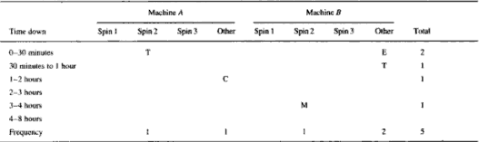

WHY to use
Check sheets for data collection are useful for process control and problem analysis. It is important to monitor the work process by collecting data that can be used to evaluate process performance and develop improvement actions. The data collected in the check sheets must be summarized in a convenient and graphical form.
Process Control – Every work process has a number of indicators on how the process is performing. Collection and later analysis of this information is an important part of monitoring a process.
Process Analysis – Troubleshooting to determine the root cause of a problem requires detailed information to clearly define the problem. Check sheets can be used to answer who, what, where, when, why, how and how many.

WHEN to use
During the measure phase this procedure can be used to measure data

HOW to use
Explained in sections above

Example

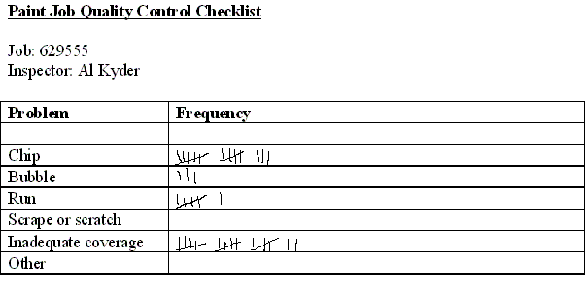

Sources/References
- http://books.google.com/books?id=eVxpo6Z7AOAC&pg=PA330&lpg=PA330&dq=check+sheet&source=web&ots=vgjnj1yd5e&sig=qgbGtr1KtzS-WcG7HwrK_Jy9Kxo#PPA323,M1
- http://www.asq.org/learn-about-quality/data-collection-analysis-tools/overview/check-sheet.html

